**WEEK 6 - REACT**

**LAB 1-** Create a new React Application with the name “myfirstreact”, Run the application to print “welcome to the first session of React” as heading of that page.

**Code(src -> App.js):**

function App() {

return (

<div>

<h1>Welcome to the first session of React</h1>

</div>

);

}

export default App;

**Output:**

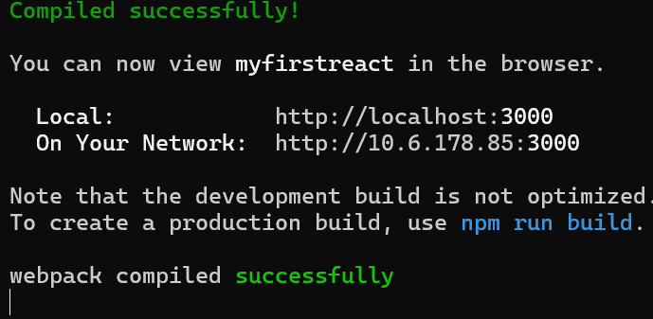

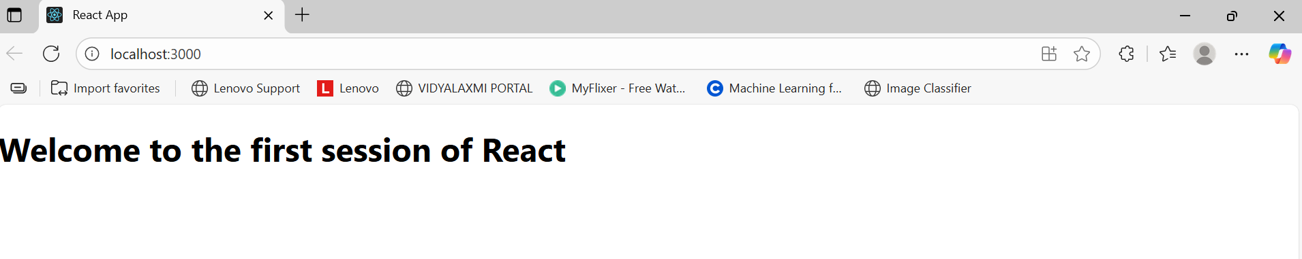

**LAB 2-** Create a react app for Student Management Portal named StudentApp and create a component named Home which will display the Message “Welcome to the Home page of Student Management Portal”. Create another component named About and display the Message “Welcome to the About page of the Student Management Portal”. Create a third component named Contact and display the Message “Welcome to the Contact page of the Student Management Portal”. Call all the three components.

**CODE:**

*src -> Components -> Home.js*

import React from 'react';

function Home() {

return (

<div>

<h2>Welcome to the Home page of Student Management Portal</h2>

</div>

);

}

export default Home;

*About.js*

import React from 'react';

function Home() {

return (

<div>

<h2>Welcome to the Home page of Student Management Portal</h2>

</div>

);

}

export default Home;

*Contact.js*

import React from 'react';

function Contact() {

return (

<div>

<h2>Welcome to the Contact page of Student Management Portal</h2>

</div>

);

}

export default Contact;

*src -> App.js*

import React from 'react';

import Home from './Components/Home';

import About from './Components/About';

import Contact from './Components/Contact';

function App() {

return (

<div>

<Home />

<About />

<Contact />

</div>

);

}

export default App;

**Output:**

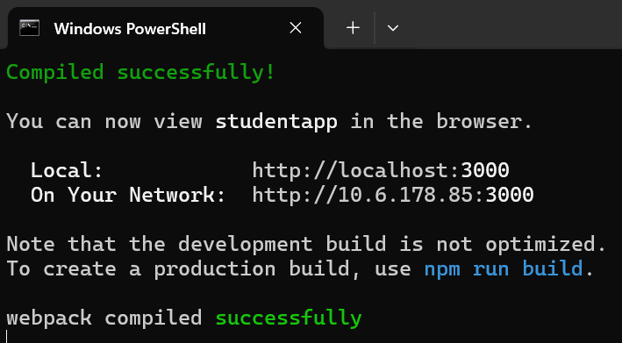

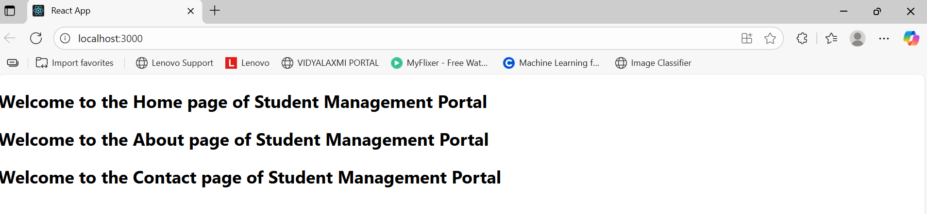

**LAB 3 -** Create a react app for Student Management Portal named scorecalculatorapp and create a function component named “CalculateScore” which will accept Name, School, Total and goal in order to calculate the average score of a student and display the same.

**Code:**

*src -> Components -> CalculateScore.js*  
import React from 'react';

import '../Stylesheets/mystyle.css';

function CalculateScore() {

const name = "Ankita";

const school = "Apex Academy";

const total = 480;

const goal = 500;

const average = (total / goal) * 100;

return (

<div className="container">

<h2>Student Score Details</h2>

<p><strong>Name:</strong> {name}</p>

<p><strong>School:</strong> {school}</p>

<p><strong>Total Marks:</strong> {total}</p>

<p><strong>Goal:</strong> {goal}</p>

<p><strong>Average Score:</strong> {average.toFixed(2)}%</p>

</div>

);

}

export default CalculateScore;

*src -> Stylesheets -> mystyle.css*.container {

background-color: #f0f8ff;

padding: 20px;

margin: 30px auto;

border: 2px solid #ccc;

width: 400px;

border-radius: 10px;

text-align: left;

font-family: Arial, sans-serif;

color: #333;

}

h2 {

text-align: center;

color: #2c3e50;

}

src -> App.js  
import React from 'react';

import CalculateScore from './Components/CalculateScore';

function App() {

return (

<div>

<CalculateScore />

</div>

);

}

export default App;

**Output:**

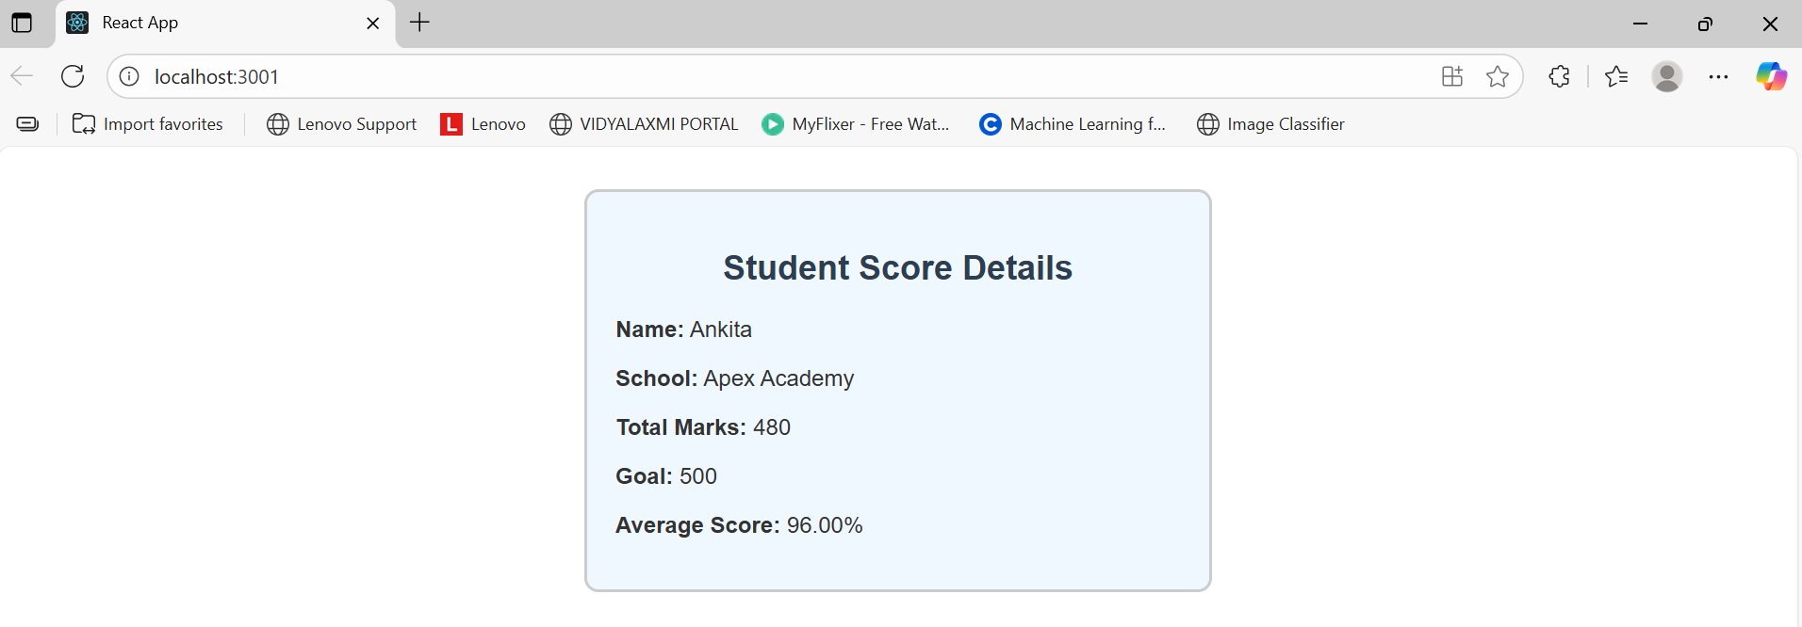

**LAB 4-** Create a new react application using *create-react-app* tool with the name as “blogapp”

**CODE:**

*Post.js*

import React from 'react';

function Post({ title, body }) {

return (

<div style={{ marginBottom: '20px' }}>

<h2>{title}</h2>

<p>{body}</p>

</div>

);

}

export default Post;

*Posts.js*

import React, { Component } from 'react';

import Post from './Post';

class Posts extends Component {

constructor(props) {

super(props);

this.state = {

posts: [],

error: null

};

}

loadPosts = () => {

fetch('https://jsonplaceholder.typicode.com/posts')

.then(res => res.json())

.then(data => {

this.setState({ posts: data });

})

.catch(error => {

this.setState({ error });

});

};

componentDidMount() {

this.loadPosts();

}

componentDidCatch(error, info) {

alert("An error occurred: " + error);

}

render() {

return (

<div>

<h1>Blog Posts</h1>

{this.state.posts.map(post => (

<Post key={post.id} title={post.title} body={post.body} />

))}

</div>

);

}

}

export default Posts;

*App.js*

import React from 'react';

import Posts from './Posts';

function App() {

return (

<div className="App">

<Posts />

</div>

);

}

export default App;

**Output:**

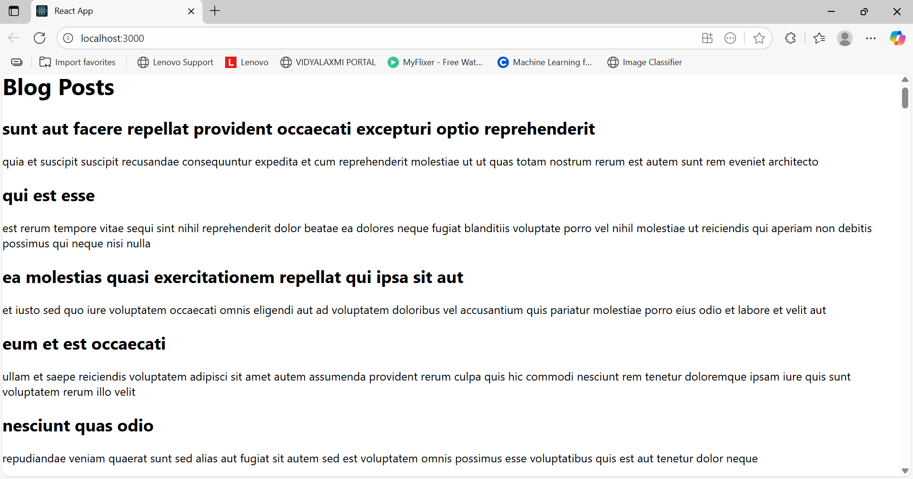

**LAB 5 -** My Academy team at Cognizant want to create a dashboard containing the details of ongoing and completed cohorts. A react application is created which displays the detail of the cohorts using react component. You are assigned the task of styling these react components.

**Code:**

*CohortDetails.module.css*

.box {

width: 300px;

display: inline-block;

margin: 10px;

padding: 10px 20px;

border: 1px solid black;

border-radius: 10px;

}

dt {

font-weight: 500;

}

*CohortDetails.js*import React from 'react';

import styles from './CohortDetails.module.css';

function CohortDetails({ name, status, startDate, endDate }) {

const statusStyle = {

color: status.toLowerCase() === 'ongoing' ? 'green' : 'blue'

};

return (

<div className={styles.box}>

<h3 style={statusStyle}>{name}</h3>

<dl>

<dt>Status:</dt>

<dd>{status}</dd>

<dt>Start Date:</dt>

<dd>{startDate}</dd>

<dt>End Date:</dt>

<dd>{endDate}</dd>

</dl>

</div>

);

}

export default CohortDetails;

*App.js*  
import React from 'react';

import CohortDetails from './CohortDetails';

function App() {

return (

<div style={{ textAlign: 'center' }}>

<h1>Cohorts Details</h1>

<CohortDetails

name="INTADMDF10 - .NET FSD"

status="Scheduled"

startDate="22-Feb-2022"

coach="Aathma"

trainer="Jojo Jose"

/>

<CohortDetails

name="ADM21JF014 - Java FSD"

status="Ongoing"

startDate="10-Sep-2021"

coach="Apoorv"

trainer="Elisa Smith"

/>

<CohortDetails

name="CDBJF21025 - Java FSD"

status="Ongoing"

startDate="24-Dec-2021"

coach="Aathma"

trainer="John Doe"

/>

</div>

);

}

export default App;

**Output:**

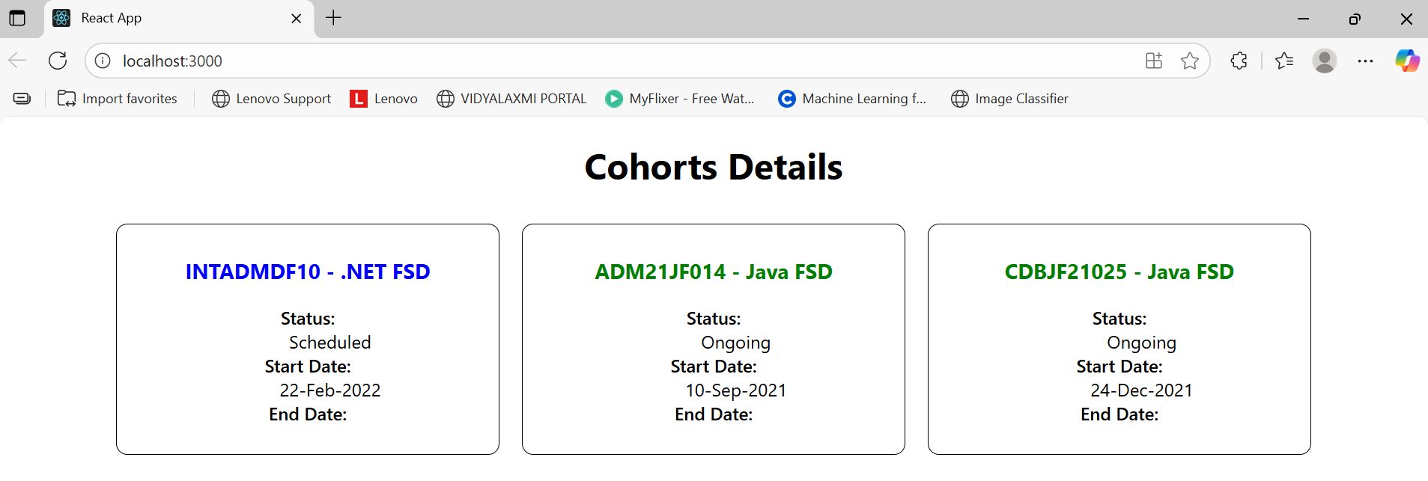

**LAB 6 -** Create a new React app using *create-react-app* tool with the as “TrainersApp”.

**Code:**

*Trainer.js*

class Trainer {

constructor(id, name, phone, email, stream, skills) {

this.trainerId = id;

this.name = name;

this.phone = phone;

this.email = email;

this.stream = stream;

this.skills = skills;

}

}

export default Trainer;

*TrainersMock.js*

import Trainer from './Trainer';

const trainers = [

new Trainer(1, "John Doe", "9876543210", "john@abc.com", "Java", ["Core Java", "Spring Boot"]),

new Trainer(2, "Jane Smith", "9988776655", "jane@abc.com", "Python", ["Flask", "Django"]),

new Trainer(3, "Aman Verma", "9123456789", "aman@abc.com", "JavaScript", ["React", "Node"])

];

export default trainers;

*Home.js*

import React from 'react';

function Home() {

return (

<div>

<h2>Welcome to Trainers Portal</h2>

<p>Use the navigation menu to view trainers.</p>

</div>

);

}

export default Home;

*TrainerList.js*

import React from 'react';

import { Link } from 'react-router-dom';

function TrainerList({ trainers }) {

return (

<div>

<h2>Trainers List</h2>

<ul>

{trainers.map(trainer => (

<li key={trainer.trainerId}>

<Link to={`/trainer/${trainer.trainerId}`}>{trainer.name}</Link>

</li>

))}

</ul>

</div>

);

}

export default TrainerList;

*TrainerDetails.js*

import React from 'react';

import { useParams } from 'react-router-dom';

import trainers from './TrainersMock';

function TrainerDetails() {

const { id } = useParams();

const trainer = trainers.find(t => t.trainerId === parseInt(id));

if (!trainer) {

return <p>Trainer not found.</p>;

}

return (

<div>

<h2>{trainer.name}</h2>

<p><strong>Phone:</strong> {trainer.phone}</p>

<p><strong>Email:</strong> {trainer.email}</p>

<p><strong>Stream:</strong> {trainer.stream}</p>

<p><strong>Skills:</strong> {trainer.skills.join(', ')}</p>

</div>

);

}

export default TrainerDetails;

*App.js*  
import React from 'react';

import { BrowserRouter, Routes, Route, Link } from 'react-router-dom';

import Home from './Home';

import TrainerList from './TrainerList';

import TrainerDetails from './TrainerDetails';

import trainers from './TrainersMock';

function App() {

return (

<BrowserRouter>

<div>

<nav>

<ul style={{ display: 'flex', gap: '20px' }}>

<li><Link to="/">Home</Link></li>

<li><Link to="/trainers">Trainers</Link></li>

</ul>

</nav>

<Routes>

<Route path="/" element={<Home />} />

<Route path="/trainers" element={<TrainerList trainers={trainers} />} />

<Route path="/trainer/:id" element={<TrainerDetails />} />

</Routes>

</div>

</BrowserRouter>

);

}

export default App;

**Output:**

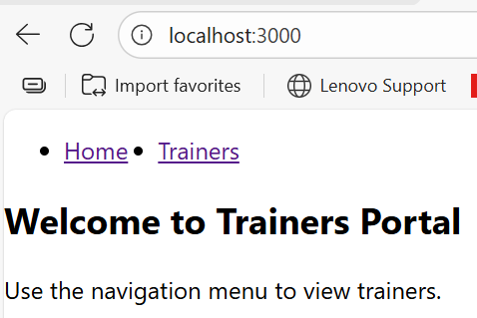 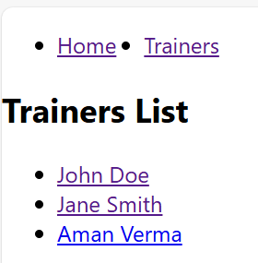

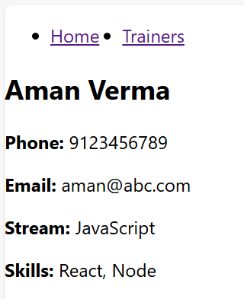

**LAB 7-** Create a React Application named “shoppingapp” with a class component named “OnlineShopping” and “Cart”.

**Code:***OnlineShopping.js*

import React from "react";

import Cart from "./Cart";

class OnlineShopping extends React.Component {

render() {

const cartItems = [

{ itemname: "Laptop", price: 70000 },

{ itemname: "Headphones", price: 2000 },

{ itemname: "Mobile", price: 15000 },

{ itemname: "Shoes", price: 3000 },

{ itemname: "Backpack", price: 1000 },

];

return (

<div>

<h2>Online Shopping Cart</h2>

{cartItems.map((item, index) => (

<Cart key={index} itemname={item.itemname} price={item.price} />

))}

</div>

);

}

}

export default OnlineShopping;

*Cart.js*import React from "react";

class Cart extends React.Component {

render() {

const { itemname, price } = this.props;

return (

<div style={{ border: "1px solid gray", padding: "10px", margin: "10px" }}>

<h3>Item: {itemname}</h3>

<p>Price: ₹{price}</p>

</div>

);

}

}

export default Cart;

*App.js*import React from "react";

import OnlineShopping from "./OnlineShopping";

function App() {

return (

<div className="App">

<OnlineShopping />

</div>

);

}

export default App;

*index.js*  
import React from "react";

import ReactDOM from "react-dom/client";

import App from "./App";

const root = ReactDOM.createRoot(document.getElementById("root"));

root.render(<App />);

**OUTPUT:**  
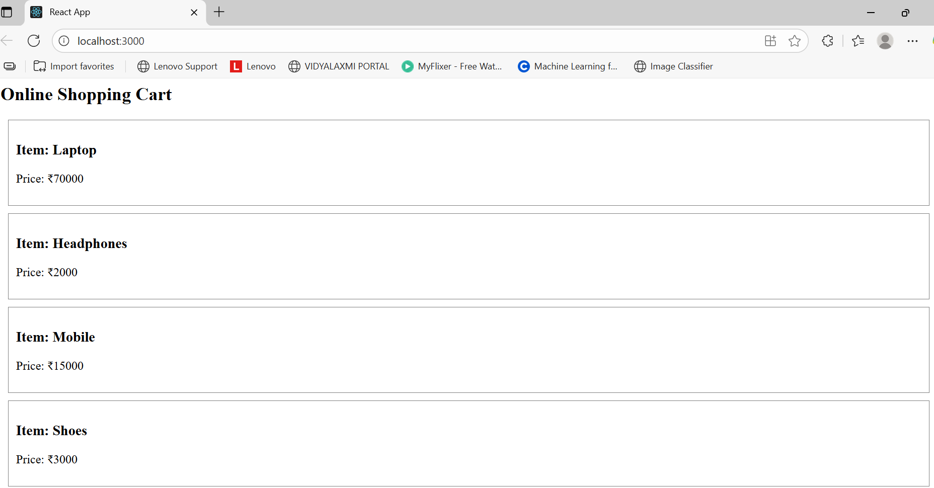

**LAB 8 -** Create a React App “counterapp” which will have a component named “CountPeople” which will have 2 methods.  
UpdateEntry() à which will display the number of people who entered the mall.  
UpdateExit() à which will display the number of people who exited the mall.

**Code:**  
*CountPeople.js*  
 import React from 'react';

class CountPeople extends React.Component {

constructor(props) {

super(props);

this.state = {

entryCount: 0,

exitCount: 0

};

}

UpdateEntry = () => {

this.setState(prevState => ({ entryCount: prevState.entryCount + 1 }));

}

UpdateExit = () => {

this.setState(prevState => ({ exitCount: prevState.exitCount + 1 }));

}

render() {

return (

<div>

<h1>People Counter</h1>

<p>People Entered: {this.state.entryCount}</p>

<p>People Exited: {this.state.exitCount}</p>

<button onClick={this.UpdateEntry}>Login</button>

<button onClick={this.UpdateExit}>Exit</button>

</div>

);

}

}

export default CountPeople;

*App.js*  
import React from 'react';

import CountPeople from './CountPeople';

function App() {

return (

<div className="App">

<CountPeople />

</div>

);

}

export default App;

**OUTPUT:  
